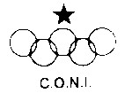 | ENTRY FORM (writable PDF) | 
Via Meda n.40  22035 Canzo (Co)  Tel. 0362-994198  Fax. 0362-941701 | XIX EDITION  ‘Old Trial Cup’ Caglio (CO)  11-12 April 2015 | 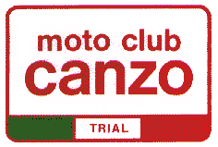

Rider data
First name: | Second Name:
Born: | Moto Club:
License n. | [ ] one event license
Address Street: N.:
Town: Zip code: Country:
E-mail: Phone n.:

Motorcyle data
Model: |  |  | Year:

 |  | Class for the Trial
 | A  Prototype |  | Motorcycles prototype 4 and 2 stroke with engine and frame to 31-12-1990 |  | Very easy  non-stop section | White
 | B  Pre ‘65/4T |  | Motorcycles built to 1965 (pre ’65) |  | Very easy  non-stop section | White
 | C  Gentlemen |  | Classic motorcycles built to 1991  Post-classic motorcycles with mono-schock and air-cooled engine. |  | Very easy non-stop section | White
 | D  Clubman |  | Classic motorcycles built to 1991  Post-classic motorcycles with mono-schock and air-cooled engine. |  | Easy non-stop section | Yellow
 | E  Expert |  | Classic motorcycles built to 1991  Post-classic motorcycles with mono-schock and air-cooled engine. |  | Hard non-stop section | Green
 | F  Open  Clubman |  | All trial motorcycles (include modern mono shock) |  | Easy non-stop section | Yellow
 | G  Open  Expert |  | All trial motorcycles (include modern mono shock) |  | Hard non-stop section | Green

The entry tax have a cost of € 75,00 for two day trial. The entry tax only for Saturday have a cost of € 40,00 and the entry tax only for Sunday have a cost of € 40,00.

Data……………… Signature………………………………………
At the start of the race

Rider number

Rider penalty

Save the completed form
and send it
(save before sending)
to the e-mail

info@motoclubcanzo.it
Fax number ++39 0362 941701
www.motoclubcanzo.it

How reach the trial in Caglio (CO)

From Turin: Highway Turin-Milan following on the west ring of Milan to direction Venice and exit to Cinisello Balsamo toward the highway Milan-Lecco direction Lecco. Exit Annone Brianza direction Cesana Brianza, follow to Erba and then follow to CANZO; passing Canzo and the country of Asso trun on left following for Caglio.

From Chiasso-Como: Follow to Lecco and then to Erba; after Erba follow for Ponte-Lambro in direction to CANZO; passing Canzo and the country of Asso trun on left following for Caglio.

From Venice: Highway Venice-Milan following on the west ring of Milan to direction Turin and exit to Cinisello Balsamo toward the highway Milan-Lecco direction Lecco. Exit Annone Brianza direction Cesana Brianza, follow to Erba and then follow to CANZO; passing Canzo and the country of Asso trun on left following for Caglio.

From Bergamo: Follow to Lecco passing the countries of Pontida, Cisano Bergamasco, Brivio. When you are in Lecco follow for Como on the highway Lecco-Milan and exit to Cesana Brianza, , follow to Erba and then follow to CANZO; passing Canzo and the country of Asso trun on left following for Caglio.

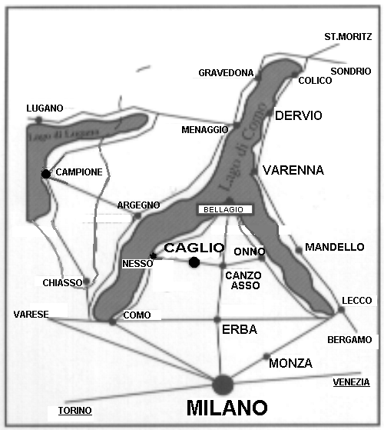

Hotels address

Sara Hotel – Via S. Valeria 22030 Caglio (CO) tel. 031-667015
Rifugio Alpetto di Torno – Loc. Pian del Tivano Sormano (CO) tel. (+39) 347 9190505 (Daniele)
Albergo Miravalle – Via Pian del Tivano n.27 22030 Sormano (CO) tel. 031-683570
Albergo Aurora – Via Pian del Tivano n.20 22030 Sormano (CO) tel. 031.683771
Albergo ristorante la Zuppiera – Via Alessandro Verza n.56 22035 Canzo (CO) tel.031 681369

For more info please call Mr.Eugenio Gatti at n. +39 0362 994198 (in the evening)



Con il patrocinio della Comunità Montana del Triangolo Lariano (Canzo – CO)

