2009 TRIAL OF NATIONS
(Male and Female World Teams Championship)
* * *
FEMALE WORLD CHAMPIONSHIP
* * *

DARFO Boario Terme September 18-19-20th 2009

The Moto Club Lazzate in collaboration with the commune of Darfo Boario terme and all the local authority of the Valcamonica renews its prestigious appointment with the high-level trial in Darfo Boario Terme (Valcamonica), organizing the TRIAL of Nations 2009, Male and Female World Teams Championship.

Appointments become a tradition for the Lazzate’s association that from years organizes unforgettable trial competitions.

Among these events they are to remember in particular the Trial of the Nations of 1998, the Grand Prix of Italy individual World Championship went off in 2002 and the European Championship 2003 who took place in Valmalenco. In 2006 to Darfo Boario Terme was performed the European Championship and the individual World Championship.

All these events were successful of public.

Just in these days the organizers are working for the definition of the last details with the objective to realize another unforgettable event as in the past editions.

Epicentre of the event will be the Secas Congress Centre.
An area of around 9000 square meters with all the necessary services, will host all the teams that will participate in the competition.

They will be to disposal of the public 10 bus shuttles that will commute through the various trial zones and the Secas Congress Centre.

During the days of the competition in the interested areas they can circulate only the authorized means of service.

Near the Congress Centre will be set-up the pressroom.

The competition will develop him in the following days:

- 18 September Female World championship
- 19 September Female Trial of Nations
- 20 September Masculine Trial of Nations

They foresee the share of around 25 Nations coming from all the continents.

USEFUL INFORMATIONS

PLACE

DARFO BOARIO TERME

CENTRO CONGRESSI SECAS

BRESCIA ITALIA

ORGANIZATION
MOTO CLUB LAZZATE - via Trento e Trieste, 15
20020 Lazzate (MI) - ITALIA
Tel./Fax: +39 02 96720762
www.motoclublazzate.it
Email mclazzate@tiscali.it

NATIONAL FEDERATION
Federazione Motociclistica Italiana www.federmoto.it

ACCOMMODATIONS BOOKING

info@ilmonticolovacanze.it
Donato.monti@libero.it

AIRPORTS

Milano Linate Km.97

Milano Malpensa Km. 140

Bergamo Orio al Serio Km.50

Verona Valerio Catullo Km 115

MOTORWAY

AUTOSTRADA A4 Milano-Venezia - Uscita Ospitaletto-Iseo Strada SS 510

Seguire indicazioni Vallecamonica - Uscita Boario Sud

RAILWAY STATION HOSPITAL

Darfo Boario Terme Esine Km 8
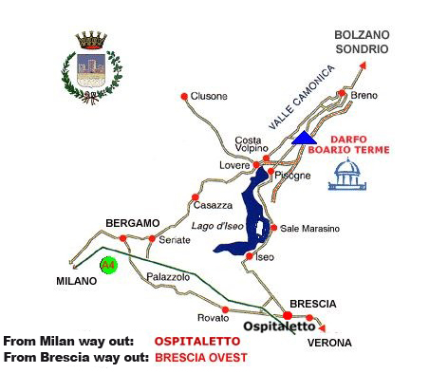

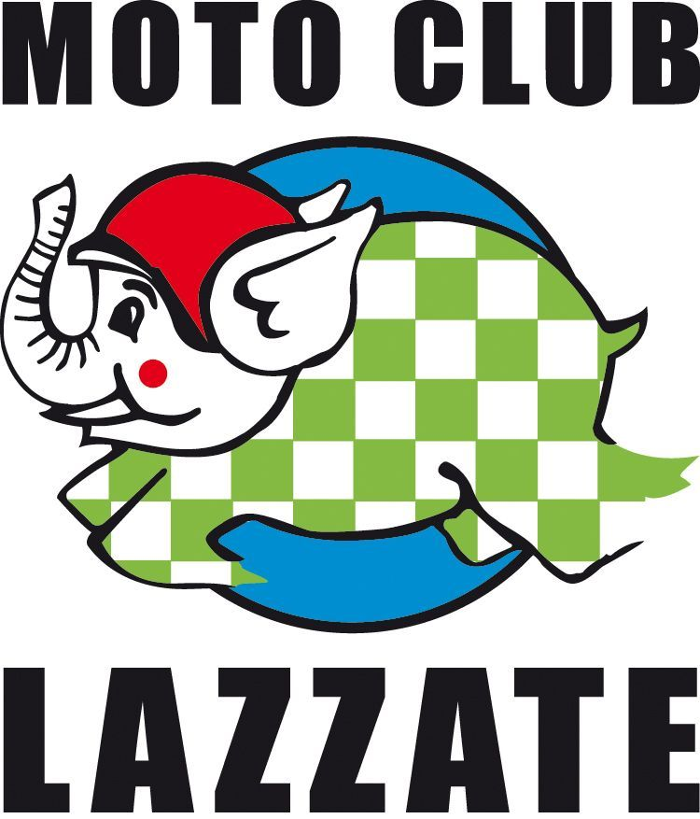

The Club is born in March of 1956 by will of a group of impassioned friends that desired to spread knowledges on the correct use of the motorcycle. Her first gymkhana competitions took place to the parish recreation centre of the village always ended with great blowouts near the cafe "Giuan del Gat", first base of the Club. Date back to that times the involvement to the first National and International motorcycle rallyes, in which the Club has also won trophies put in prize by the Chairmanship of the Council of Ministers.

Afterwards six well attempted National Motorcycle rallyes titled "Luoghi Voltiani" (Alessandro Volta's places),have been organized. From the seventies they began to organize the first Trial competitions, at the equipped area "wood of Batù", (today municipal ownership) that will become in the time the principal activity of the association. In the succession of the years he reaches the 1989 when the association organizes the World Championship of of Trialsin (bicycle Trial) to the Idroscalo in Milan. With this sporting event, began a new era, with the organization of world Championships of Trial. In the year 1998 the Trial of Nations organized in Valmalenco, that saw the presence of the five continents; in the same place, in the year 2002 the Individual World Championship and in the year 2003 the Individual European Championship; in the year 2004 the World Championship of Trial Indoor to the B.P.A. Palace of Pesaro, in the year 2005 to the Assago Palaforum and; in 2006, to the Algida Palace in Livorno.
In the year 1998 begun for the association the period of big notorieties, near impassioned of the whole globe: the international televisions started telecasts, so much to make to become the events organized popular all over the world. In the same year a section of trial was founded in Valtellina, which the name of Reziatrial has been given. The world successes recorded by the Motion Club Lazzate, have not prevented its partners to continue to actively be present in all the activities proposed in the territory of the Commune, supporting her with the same spirit and enthusiasm with which the Motion Club organizes and participates in the world events.
LIST OF NATIONAL AND INTERNATIONAL COMPETITIONS

ORGANIZED BY MOTO CLUB LAZZATE

- World Trialsin Championship (Biketrial) Idroscalo Milano 1989
- Trial of Nations Valmalenco 1998
- World Trial Outdoor Championship Valmalenco 2002
- European Trial Outdoor Championship Valmalenco 2003
- World Trial Indoor Championship BPA palace Pesaro 2004
- World Trial Indoor Championship Forum Assago 2005
- World Trial Indoor Championship Pala Algida Livorno 2006
- World Trial Outdoor Championship Darfo Boario Terme 2006
- European Trial Outdoor Championship Darfo Boario Terme 2006
- World Trial Indoor Championship Forum Assago 2006
- World Trial Indoor Championship Forum Assago 2007
- European Trial Outdoor Championship Lazzate 2007
- World Trial Indoor Championship Forum Assago 2008
- Italian Trial Junior Championship Bregnano 1981
- Supertrial Championship Valgerola 1992
- Supertrial Championship Valmasino 1993
- Campionato Supertrial Valsassina 1990
- Italian Trial Championship Valgerola 1994
- Italian Trial Championship Cosio Valtellino 1997
- Italian Trial Championship Madesimo 2001
- Italian Trial Championship Colorina 2000
- Italian Trial Championship Valmalenco 2008
- Italian Trial Championship Campodolcino 2004
- Italian Trial Championship Darfo Boario Terme 2005
- Italian Trial indoor Championship Morbegno 2005
- Vintage Trial Championship Delebio 2008
- Italian Trial Indoor Championship Cantù 2007,2008,2009
- Italian Trial Indoor Championship Milano 2003,2006,2007
- Italian Trial Indoor Championship Lazzate 2008
- Italian Hard Trial Championship Lazzate 2009
- Italian Biketrial Championship Lazzate 1986,1987,2008,2009
- Italian Biketrial Championship Alpe del Vicerè 1986
- Italian Biketrial Championship Monte Croce 1985
- I Italian Biketrial Championship Cantù 2008
- Italian Snow Mobile Championship Val D'Intelvi 1981
- Italian Short Track Championship Lazzate 1982
- Italian Short Track Championship Val D'Intelvi 1983
- 6 National Bike Rallyes named “Luoghi Voltiani” Lazzate
- 5 Interregional Bike Rallyes Lazzate
- Around 150 regional championship in several
specialties (Minicross, Minimoto, Trial, Gymkhanas) Lazzate

